LABORATORY EXERCISE №7
Topic 1: Creation of a simple network configuration

Basics:
Local area network (LAN). A LAN is a way to share files and devices between multiple computers. LAN represent a set of connected together personal computers (so called - nodes or workstations within network) and other automatic data processing devices, such as printers, scanners, fax machines and modems within a relatively small area - building enterprise, organization or individual units, etc. The LAN uses IP addresses to route data to different destinations on the network. An IP Address is a 32-bit numeric address written as four numbers separated by periods (For example, 1.160.10.240).

Advantages:
- Sharing devices such as printers saves money and time.
- Software licenses are likely to be cheaper than buying several standalone licenses.
- Files can easily be shared between users.
- Network users can communicate by email and instant messenger.
- Security is good - users cannot see other users files unlike on stand-alone machines.
- Data is easy to backup as all the data is stored on the file server.
Disadvantages:
- Purchasing the network cabling and file servers can be expensive.
- Managing a large network is complicated, requires training and involving network managers.
- If the file server breaks down the files on the file server become inaccessible. Email might still work if it is on a separate server. The computers can still be used but are isolated.
- Viruses can spread to other computers throughout a computer network.
- There is a danger of hacking, particularly with wide area networks. Security procedures are needed to prevent such abuse, eg a firewall.

Types of LAN.
According to the principle of joint use of resources in a LAN are divided into two common models:
- Peer to Peer (P2P)
- Client- Server

Peer to Peer
Peer to peer networks are good to connect small number (around 10) of computer and places where high level of security is not required. Peers (nodes) are equally privileged, equipotent participants in the application. Peers make a portion of their resources, such as processing power, disk storage or network bandwidth, directly available to other network participants, without the need for central coordination by servers or stable hosts, so network management functions are transferred one by one from one workstation to another. This approach facilitates the work of the user groups, but the overall network performance may drop.

Advantages of P2P model:
- Peer networks are relatively easy to deploy, and they are much cheaper than the client / server model.
- P2P is more reliable as central dependency is eliminated. Failure of one peer doesn’t affect the functioning of other peers affected.
- There is no need for system administrator. Every user has a permission to control their shared resources.
Disadvantages of P2P model:
- The whole system is decentralized thus it is difficult to administer. That is one person cannot determine the whole accessibility setting of whole network.
- Security in this system is very less viruses, spywares, trojans, etc. malwares can be easily transmitted over network.
- Data recovery or backup is very difficult. Each computer should have its own back-up system.

Client-Server
Client/server architecture is a computing model in which the server hosts, delivers and manages most of the resources and services to be consumed by the client. This type of architecture has one or more client computers connected to a central server over a network or Internet connection. Servers are typically high performance computers, possibly with multiple processors operating in parallel, with high-capacity hard drives, high-speed network interface card etc. The network can be connected to multiple servers.

Advantages of Client-Server model
- Centralization: Unlike P2P, where there is no central administration, here in this architecture there is a centralized control. Servers help in administering the whole set-up. Access rights and resource allocation is done by servers.
- Proper Management: All the files are stored at the same place. In this way, management of files becomes easy. Also it becomes easier to find files.
- Back-up and Recovery possible: As all the data is stored on server its easy to make a back-up of it. Also, in case of some break-down if data is lost, it can be recovered easily and efficiently.
- Upgradation and Scalability: Changes can be made easily by just upgrading the server. Also new resources and systems can be added by making necessary changes in server.
- Accessibility: From various platforms in the network, server can be accessed remotely.
- As new information is uploaded in database , each workstation need not have its own storage capacities increased (as may be the case in peer-to-peer systems). All the changes are made only in central computer on which server database exists.
- Security: Rules defining security and access rights can be defined at the time of set-up of server.
- Servers can play different roles for different clients.

Disadvantages of Client-Server model:
- Congestion in Network:Too many requests from the clients may lead to congestion, which rarely takes place in P2P network. Overload can lead to breaking-down of servers.
- Client-Server architecture is not as robust as a P2P and if the server fails, the whole network goes down. Also, if you are downloading a file from server and it gets abandoned due to some error, download stops altogether. However, if there would have been peers, they would have provided the broken parts of file.
- Cost: It is very expensive to install and manage this type of computing.
- You need professional IT personal to maintain the servers and other technical details of network.

Network topologies
The configuration (wiring topology) determines how the network workstations are located and how they are interconnected. Basic and most common LAN topologies:
- Bus topology
- Ring network
- Star topology

Bus topology
In a bus topology, all network nodes are equally interconnected via one open cable. This cable can support only one channel and is called the Bus, which does not require the installation of external electronic devices and connecting all network nodes as equal devices. All connected devices "listen" bus traffic and only accept packets addressed to them. Both ends of the Bus-cable must end with a termination resistors, called terminators. These resistors are designed to prevent relative reflection signals. When a station transmits a signal in the cable, this signal extends in both directions. If terminators is not set, the signal reaches the end of the bus
it reverses its direction, and fs a result, a transmission from single node can fully capture all network bandwidth and interfere with transmissions from others.
Advantages of bus topology
- It works well when you have a small network.
- Easiest network topology for connecting computers or peripherals in a linear fashion.
- Requires less cable length than a star topology.
Disadvantages of bus topology
- Difficult to identify the problems if the whole network goes down.
- It can be hard to troubleshoot individual device issues.
- Terminators are required for both ends of the main cable.
- Additional devices slow the network down.
- If a main cable is damaged, the network fails or splits into two.

Ring topology
In a ring network each device is connected to two other devices, this forms a ring for the signals to travel around. Each packet of data on the network travels in one direction and each device receives each packet in turn until the destination device receives it. By recognizing the necessary data, workstation copies it in an internal buffer. Data travels around the network, in one direction. Sending and receiving of data takes place by the help of Token. Token contains a piece of information which along with data is sent by the source computer. This token then passes to next node, which checks if the signal is intended to it. If yes, it receives it and passes the empty to into the network, otherwise passes token along with the data to next node. This process continues until the signal reaches its intended destination. The nodes with token are the ones only allowed to send data. Other nodes have to wait for an empty token to reach them. This network is usually found in offices, schools and small buildings.
Advantages of Ring Topology
- Each node gets to send the data when it receives an empty token. This helps to reduces chances of collision. Also in ring topology all the traffic flows in only one direction at very high speed.
- Even when the load on the network increases, its performance is better than that of Bus topology.
- There is no need for network server to control the connectivity between workstations.
- Additional components do not affect the performance of network.
- Each computer has equal access to resources.
Disadvantages of Ring Topology
- Each packet of data must pass through all the computers between source and destination.
- If one workstation or port goes down, the entire network gets affected.
- Network is highly dependent on the wire which connects different components.

Star topology
All the components of network are connected to the central device called “hub” which may be a hub, a router or a switch. All the workstations are connected to Hub with a point-to-point connection, and every computer is indirectly connected to every other.
All the data on the star topology passes through the central device before reaching the intended destination. Hub acts as a junction to connect different nodes present in Star Network, and at the same time it manages and controls whole of the network. Depending on which central device is used, “hub” can act as repeater or signal booster.
Advantages of Star Topology
- Better performance, signals don’t necessarily get transmitted to all the workstations. A sent signal reaches the intended destination after passing through no more than 3-4 devices and 2-3 links.
- Easy to connect new nodes or devices. In star topology new nodes can be added and removed easily without affecting rest of the network.
- Centralized management helps in monitoring the network.
- Failure of one node or link doesn’t affect the rest of network. At the same time its easy to detect the failure and troubleshoot it.
Disadvantages of Star Topology
- Too much dependency on central device has its own drawbacks. If it fails whole network goes down.
- The use of hub, a router or a switch as central device increases the overall cost of the network.
- Performance and as well number of nodes which can be added in such topology is depended on capacity of central device.

Laboratory Practice 1:
Setting up a local network and file sharing

Getting Started
- Ensure you are using the main administrative account
- Confirm that you have the network interface card or an on-the-motherboard network port and Network cables for each computer
- If I would like to connect more than two workstations ensure that you have Network hub or other RJ-45 connecting device

Step 1: Connecting the network hardware and cables
- Set up and turn on the power for the network hub or other networking device.
- Connect the computers to the networking device. If a crossover cable is used, connect the cable to the RJ45 network ports on each computer.
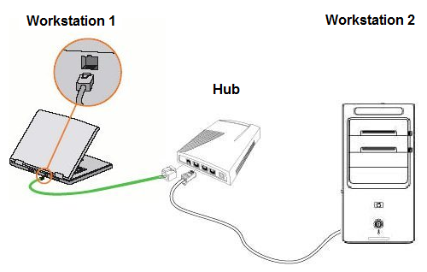
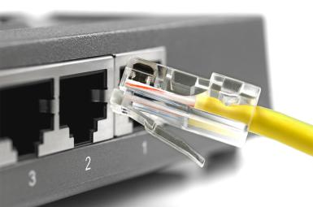

Figure 1. Connection of networking cables

- Connect the computer power cords and turn the computers on.

Step 2: Turning on Network discovery and file sharing
- Click Start , and then click Control Panel.
- Under Network and Internet, click Choose Homegroup and sharing options.
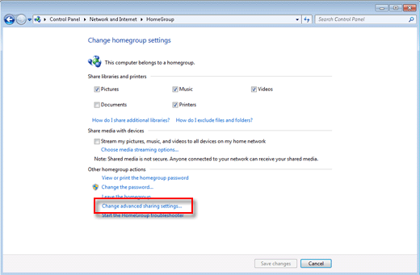
- In the Homegroup settings window, click Change advanced sharing settings.

Figure 2. Homegroup settings
- Turn on network discovery and file and printer sharing.
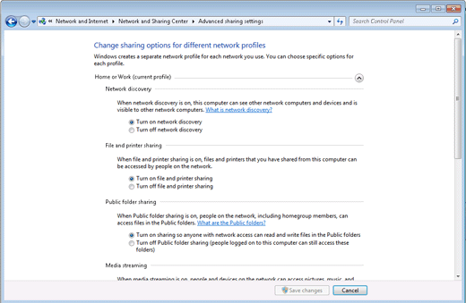
Figure 3. Sharing settings

- Click Save changes.
Step 3: Sharing drives, folders, and files
To share non-public folders with other computers on a local network
- Click Start , and then click Computer.
- Browse to the folder you want to share.
- Right-click the folder, select Share with, and then click Homegroup (Read), Homegroup (Read/Write), or Specific people.

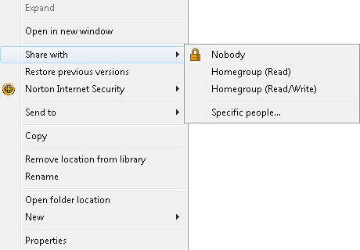

Figure 4. Share with menu options

• If you chose Specific people, the File Sharing window displays.
• Click the down arrow and select the account you want to share with, and then click Add.
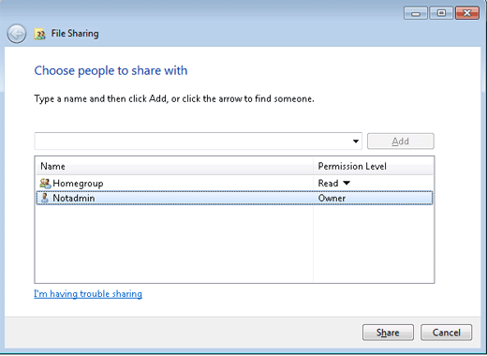

Figure 5. File sharing options

- Click an arrow under Permission Level to set the permission level for each account or group.
- Click Share.

Step 4: Testing a local network
Open the Windows 7 network window and browse through the shared folders in each computer on the network. If the computer is able to read and access files from a remote computer, the remote computer is set up correctly. Browse to every available computer from each computer on the network. If there are any issues, go back through these steps and verify that the settings are correct.

Step 5: Accessing shared files and directories
- Ensure network discovery and file sharing is turned On.
- Click Start, click Control Panel, click Network and Internet, and then click Network and Sharing Center.
- Double-click Network.

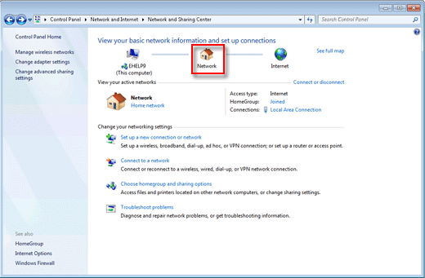
Figure 6. Network and Sharing Center

- The Network window opens and displays computers with shared folders that are detected on local networks.

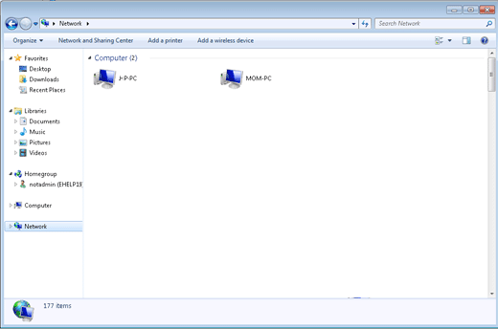
Figure 7: Computers on the network with shared folders

- Double-click the computer you want to access.

Note: When accessing shared files or directories the following error message window may display:

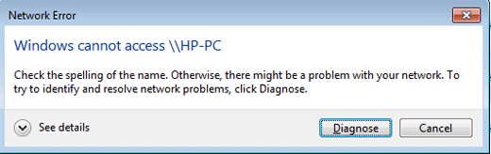

To resolve the error, verify the following:
- The account has the proper permissions to access the computer.
- The computer name and account name are spelled correctly.
- Make sure that Firewall software on any connected computer is set to allow access.

